A typical sales RECEIPT (this is just a simplified assumption for illustration purpose).

Kedai Makanan Good Food
Order No: |  |  |  |  |  |  |  |  | Date:
Customer No:
Order list
No. | Item Code |  | Description |  |  |  | Quantity | Unit Price |  | Total Price
1
2
3
4
5
6
Sub-Total
GST
Service Charge
Grand Total

This is a typical ER diagram for an order processing system (based on certain assumptions).

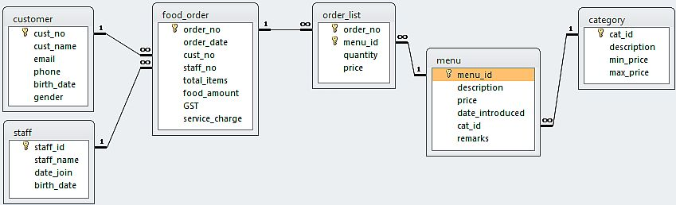

In this scenario,
- customer can make one or more orders for food
- service staff take one or more orders
- food_order can have one or more list of items
- the order_list item must be chosen from the menu
- each item in the menu belongs to a category of food

Now imagine if you are the owner of such a business. What would you want to know about all the data collected so that you can run your business better?

Construct a list of 15 reports/facts that would help you to manage and advance your company.
(To be presented by the 3rd practical)

